COMP 2313 DATA STRUCTURES CODE ASSIGNMENT

|  |  |
| --- | --- |
| ***Assignment Name: EXTRA CREDIT QUESTION*** | ***Student Name :****Mustafa Senih Topsakal* |
| ***Assignment Date:****11/30/2020* | ***Student id :****181220146* |

# Problem

##### A Dictionary implementation using Binary Search Trees

**Program requirements and structure**

You should be able to do the following:

* Add dictionary entries
* Search for an entry
* Print the whole dictionary

You will be using the **.compareTo**method from the String class in order to move through your tree.

Recursive method to print the tree in **inorder**traversal (you need little mods below code)

public void printTree(Node root){

if(root != null){

printTree(root.getLeftChild());

System.out.println(root.toSting( ));

printTree(root.getRightChild());

}

}

# Challenges

* Add dictionary entries
* Search for an entry
* Print the whole dictionary

# Code

import java.util.ArrayList;

public class Main {

static ArrayList<Node> constructTrees(int start, int end)

{

ArrayList<Node> list=new ArrayList<>();

if (start > end)

{

list.add(null);

return list;

}

for (int i = start; i <= end; i++)

{

ArrayList<Node> leftSubtree = constructTrees(start, i - 1);

ArrayList<Node> rightSubtree = constructTrees(i + 1, end);

for (int j = 0; j < leftSubtree.size(); j++)

{

Node left = leftSubtree.get(j);

for (int k = 0; k < rightSubtree.size(); k++)

{

Node right = rightSubtree.get(k);

Node node = new Node(i);

node.left = left;

node.right = right;

list.add(node);

}

}

}

return list;

}

static void preorder(Node root)

{

if (root != null)

{

System.out.print(root.key+" ") ;

preorder(root.left);

preorder(root.right);

}

}

public static void main(String args[])

{

ArrayList<Node> totalTreesFrom1toN = constructTrees(1, 3);

System.out.println("EXTRA CREDITS ARE THE BEST! ");

for (int i = 0; i < totalTreesFrom1toN.size(); i++)

{

preorder(totalTreesFrom1toN.get(i));

System.out.println();

}

}

}

class Node

{

int key;

Node left, right;

Node(int data)

{

this.key=data;

left=right=null;

}

};

# Outputs

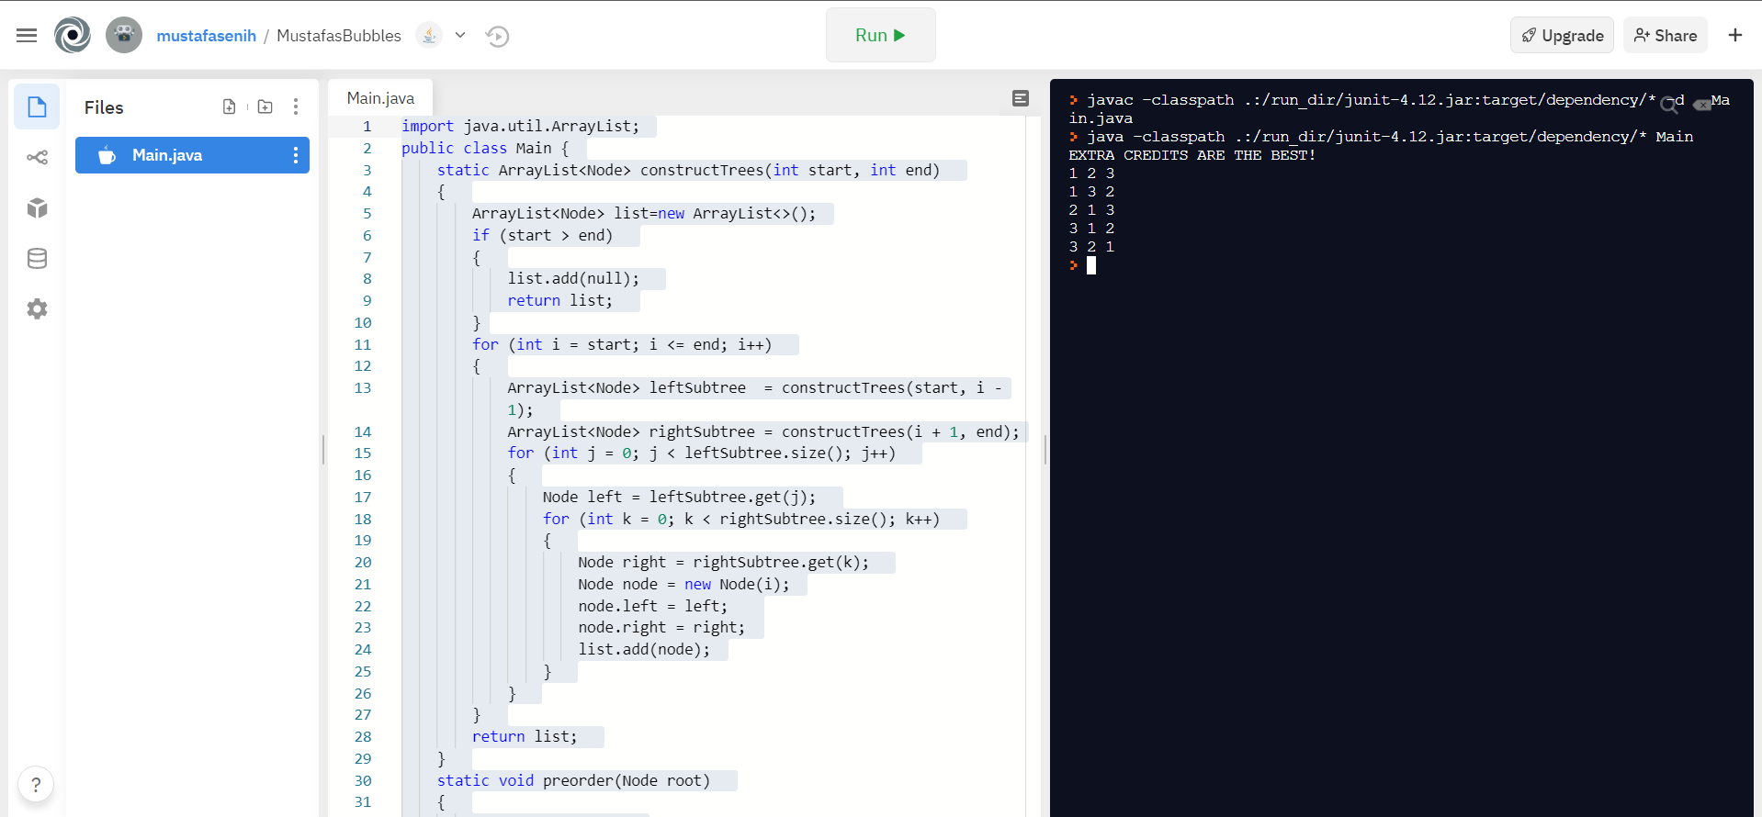

Figure Output Screen of the Odd Numbers Question

# REPL.IT LINK

[Repl.it - MustafasBubbles](https://repl.it/@mustafasenih/MustafasBubbles#Main.java)